**Project Planning Phase**

**Project Planning Template (Product Backlog, Sprint Planning, Stories, Story points)**

|  |  |
| --- | --- |
| Team ID | PNT2022TMID41556 |
| Project Name | Project **-** AI-powered Nutrition Analyzer for Fitness Enthusiasts |

**Product Backlog, Sprint Schedule, and Estimation (4 Marks)**

Use the below template to create product backlog and sprint schedule

|  |  |  |  |  |  |  |
| --- | --- | --- | --- | --- | --- | --- |
| **Sprint** | **Functional**  **Requirement (Epic)** | **User Story**  **Number** | **User Story / Task** | **Story Points** | **Priority** | **Team Members** |
| Sprint-1 | **Data Collection &**  **Image Processing** |  |  |  |  |  |
| Sprint-1 |  | USN-1 | Collect images of different food items organized into subdirectories based on their respective names | 3 | Medium | Babu |
| Sprint-1 |  | USN-2 | Import and configure the Image data generator library from Keras | 3 | Medium | Siva |
| Sprint-1 |  | USN-3 | Apply Image data generator functionality to training set and testing set | 5 | High | Imran |
| Sprint-1 |  | USN-4 | Improving the image data that suppresses unwilling distortions or enhances some image features important for further processing | 3 | Medium | Jeeva |
| **Sprint** | **Functional**  **Requirement (Epic)** | **User Story**  **Number** | **User Story / Task** | **Story Points** | **Priority** | **Team Members** |
| Sprint-2 | **Model Building &**  **Testing** |  |  |  |  |  |
| Sprint-2 |  | USN-5 | Importing the model building libraries and Initializing the model | 5 | High | Babu |
| Sprint-2 |  | USN-6 | Adding CNN layers, Dense layers & other necessary layers and Compile the model | 5 | High | Siva |
| Sprint-2 |  | USN-7 | Train & Test the model based on the image dataset | 3 | Medium | Imran |
| Sprint-3 | **Application building** |  |  |  |  |  |
| Sprint-3 |  | USN-8 | Create HTML pages to design the front-end part of the web page | 5 | High | Jeeva |
| Sprint-3 |  | USN-9 | Create the flask application and loading the model file | 5 | High | Babu |
| Sprint-3 |  | USN-10 | Routing to the HTML page and Running the application | 5 | High | Siva |
| Sprint-4 | **Cloud integration** |  |  |  |  |  |
| Sprint-4 |  | USN-11 | Train the model on Cloud | 5 |  | Imran,Jeeva |

**Project Tracker, Velocity & Burndown Chart: (4 Marks)**

|  |  |  |  |  |  |  |
| --- | --- | --- | --- | --- | --- | --- |
| **Sprint** | **Total Story Points** | **Duration** | **Sprint Start Date** | **Sprint End Date (Planned)** | **Story Points**  **Completed (as on**  **Planned End Date)** | **Sprint Release Date (Actual)** |
| Sprint-1 | 20 | 6 Days | 24 Oct 2022 | 29 Oct 2022 | 20 | 29 Oct 2022 |
| Sprint-2 | 20 | 6 Days | 31 Oct 2022 | 05 Nov 2022 | 20 | 05 Nov 2022 |
| Sprint-3 | 20 | 6 Days | 07 Nov 2022 | 12 Nov 2022 | 20 | 12 Nov 2022 |
| Sprint-4 | 20 | 6 Days | 14 Nov 2022 | 19 Nov 2022 | 20 | 19 Nov 2022 |
|  |  |  |  |  |  |  |

**Velocity:**

Imagine we have a 10-day sprint duration, and the velocity of the team is 20 (points per sprint). Let’s calculate the team’s average velocity (AV) per iteration unit (story points per day)

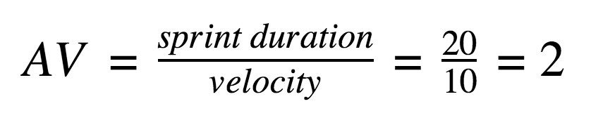

**Burndown Chart:**